22/09/07

SHORT COURSE

MANAGEMENT SYSTEM

By Trent Jackson

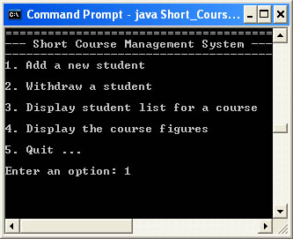

Revision: 0.01 (Text console-based version)
Platform: Windows / Mac / Linux
Language: Java
License: Public domain
Release date: 22/09/07
Dependencies: Java runtime 1.5 or higher

Launching the software ……………...……………………………………3
Using the software ……………...……………………………………….…3
Adding a new student ……………...………………………………...……4
Withdrawing a student ……………...……………………………….……4
Displaying a list of students for a course …………………………………5
Displaying course figures …………………………………………….……5

Launching The Software

The system is executed, and entirely operated at command line level. The text-based console needs to be launched and the class directory needs to be accessed. Windows users should type the following at the command line prompt ...

- C:\>Java Short_Course_Management

Using The Software …

Fig. 1: Main Menu

Fig.1 depicts a screen grab of the main menu that you should see when it’s launched. A total of 5 self-explanatory options can be seen – the user is expected to make their selection at the prompt, using numerical keys (1-5); followed by pressing enter.

After any option has completed, the system will always return to the main menu awaiting further command. Selecting option 5 will terminate the program. But before actual termination occurs, all relevant data will be saved to a flat-file database, ready to be read back in during at the start of next program execution.

Adding a New Student

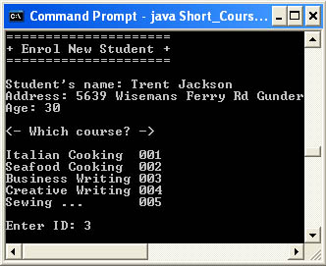
Fig. 2: Add student option

As can be seen above – adding a new student to the system is an afternoon’s snack! The system will first prompt you for their name, followed by address & age. After which you will be asked to select a course ID from a list (see fig.2)

Before the student is actually enrolled in the course, the system will do some checking to see whether or not this particular student already exists, i.e. already enrolled in this course or in another course. If the student is already enrolled in the course, the enrollment will be rejected. Alternatively, if the student is enrolled in another course, they will receive a 20% discount on their current course fees. Further discount eligibility occurs when the student is aged 50 or over. This results in a further reduction of $100.

Withdrawing a Student

Withdrawing a student is accomplished in a near identical fashion as to adding one. The only real difference is that, you will only be prompted for the student’s name and the course they’re in. After which the system will search for the student, and if found, a suitable notification message will be shown to indicate success, otherwise failure if the system was unable to locate this person.

Displaying List of Students For a Course

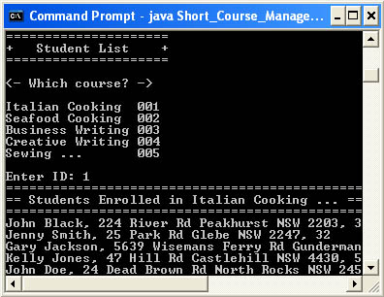
Fig. 3: Student listing

This feature allows the user to bring up an entire list of students & their details for any given course. The system will prompt for a course ID, after which is will print the list.

Displaying Course Figures

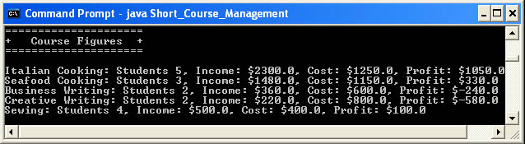
Fig. 3: Course figures

Upon selecting this option from the menu (option 4) – the system will print out to the screen a comprehensive list of financial figures. But, also, included in this list is a head count of students for each given course. The system diverts directly back to the main menu at the end of this list.

